1.Create a comparison table listing the main differences between DDR3, DDR4, and DDR5 RAM, including speed, voltage, and typical use cases.

Feature | DDR3 | DDR4 | DDR5
Release Year | 2007 | 2014 | 2020
Base Frequency | 800–1600 MHz | 2133–2400 MHz | 4800–5200 MHz
Max Consumer Frequency | 2400 MHz | 3200–4000 MHz | 6400–8400 MHz
Operating Voltage | 1.5V / 1.35V | 1.2V | 1.1V
Module Capacity | Up to 8–16GB | Up to 16–64GB | Up to 128GB (server-grade)
Typical Use Cases | Budget PCs, office work | Gaming, 4K video editing, mainstream laptops | High-end gaming, 8K video editing, servers, data science

2.Open your laptop or desktop (with power disconnected), locate the RAM slots, and take a clear photo of the installed RAM module. Reinstall the RAM module and verify that your system boots up successfully.<br><br><em><strong>Hint:</strong> Refer to your device manual or a trusted YouTube guide if unsure about RAM removal and installation steps.</em>
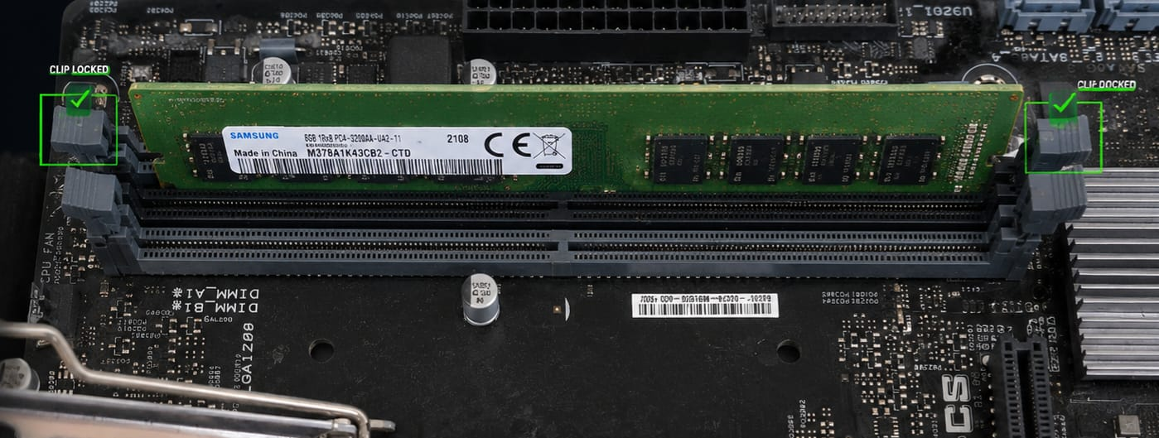
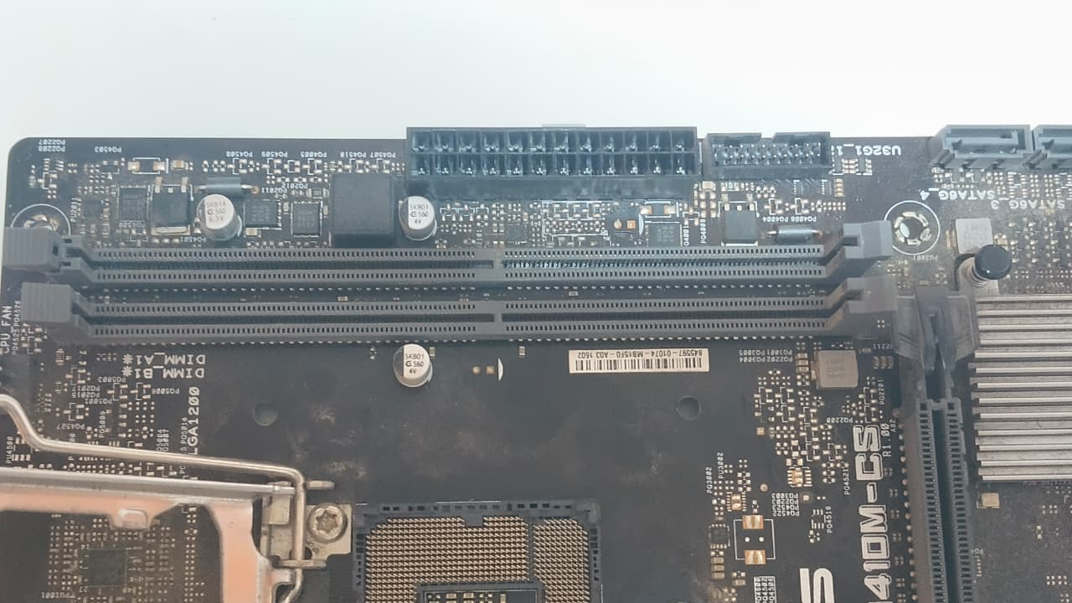

3.List three key differences between HDD, SSD, and NVMe storage types, and for each, name one app or use case (from apps you use daily) that would benefit most from that storage type.

HDD vs SSD vs NVMe Storage Differences
Feature | HDD | SSD (SATA) | NVMe SSD
Speed | 80–160 MB/s | 500–600 MB/s | 2000–7000+ MB/s
Durability | Mechanical, prone to shock damage | No moving parts, shock-resistant | Same as SSD, but faster
Cost per GB | Cheapest | Moderate | Highest
Best Use Case | Bulk storage, backups | OS, gaming, everyday apps | High-performance workloads, video editing, servers
Daily App Example | Storing movies/music | Faster booting Windows & loading PUBG | Editing/rendering videos in Premiere Pro or running Free Fire with instant load times

4. Remove the storage drive (HDD or SSD) from your system, take a photo of the connector type (SATA, M.2, or NVMe), and reinstall the drive. Confirm that your device recognizes the storage after reassembly.<br><br><em><strong>Constraint:</strong> Only perform this task if you have access to a device you are allowed to open. If not, find and share a YouTube video link showing the process for your laptop/PC model.</em>
